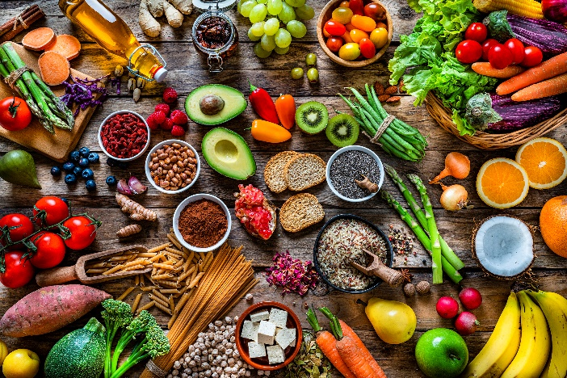
Eat More
Plants Challenge!

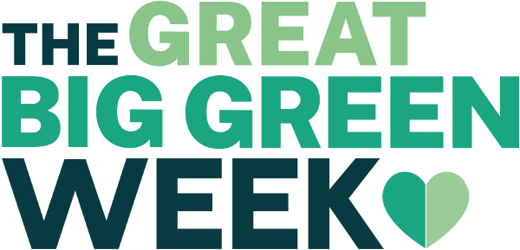

Frome Valley Medical Centre
Do you accept the challenge to eat more plants?
WHAT TO DO?
BASELINE
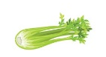
Spend 3 days measuring your baseline of whole plant foods you eat each day. This might be fresh fruit and vegetables, it also includes fresh herbs, as well as (unprocessed, unsalted) nuts & seeds and whole grains e.g. pearl barley & whole oats and legumes such as lentils, beans etc. Do an average of your 3 days to find out what your baseline is e.g.
Day 1: 4 (apple, celery, potato, orange)
Day 2: 5 (apple, cabbage, potato, orange, carrot)
Day 3: 3 (orange, carrot, cucumber)
We’re not so interested in the quantity of the plants you eat but the range!

The average would be: (4 + 5 + 3 = 12) divided by 3 = 4

THE CHALLENGE
Then set yourself the challenge of trying to consciously increase the number of whole plant foods that you eat for a 5 day period. Then do the same as before, do an average of how many you ate each day and see how you did and whether you felt better after making the change?

TIPS TO HELP:
Buy things you like! But also try things you haven’t tried before and walk past in the supermarket. Give something new a go!
It may be that if you don’t eat any nuts or seeds there are loads of new foods you could incorporate – you can add them to salads or have them with yoghurt instead of a sweet dessert after a meal or if you feel the need to snack between meals have them instead of crisps or chocolate.
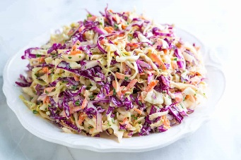
Maybe you could make a homemade coleslaw dressed with olive oil and balsamic vinegar by grating carrot, cabbage (red or green) & red onion together. You could also put other things in like celeriac or parsnip which you may be surprised to know you can eat raw or adding herbs like coriander or fennel. If you have a food blender there is a grater blade that comes with it that makes grating vegetables quick!
You might switch your morning toast or breakfast cereal for some yoghurt, berries and nuts. Breakfast cereals are often high in sugar and other highly refined carbohydrates which are not good for our bodies, giving us a sugar high after eating which can lead to hunger, low energy levels and even low mood when they dip again.
Lentils, carrots, oats, beans, onions and bananas are some of the cheapest whole plant foods if you’re wondering where to start.
Why do this?????

For thousands of years humans have lived on whole foods – hunting and gathering and farming and eating stuff that looks like it has come out of the ground not so long ago. In recent decades our highly processed food industry has added sugar, salt and fat to our food and stripped away lots of the nutrients and fibre from the original foods until they’re unrecognisable.
Is it any wonder we’ve seen the rise we have in diabetes, high blood pressure, obesity, strokes, heart disease, dementia, cancer (note: many cancers are made more likely with obesity) & arthritis? So, eating more whole plants foods is not some kind of health spree, it is a return to nutritious whole foods that our human bodies need, often replacing ultra-processed stuff that is doing our bodies long term harm.
As well as the diseases mentioned above, there is increasing evidence that eating a diet rich in whole plant foods helps your mental health and also reduces the harms of nasty viruses like Covid on your body (see final page)
For evidence about diet and mental health – see this link:
https://drchatterjee.com/you-are-what-you-eat/
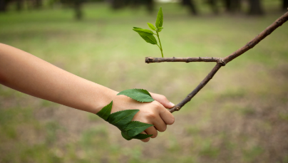
To see Dr Judson’s vlog on connecting more with nature including in the foods you’re eating see these links:
(330) Dr Rob's Rerooting - YouTube
Dr Rob's Rerooting | Facebook
We hope you take up the challenge and maybe some of the habits may stick!
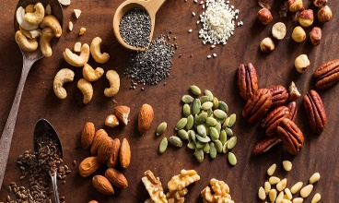
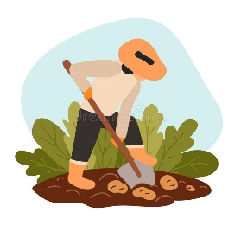
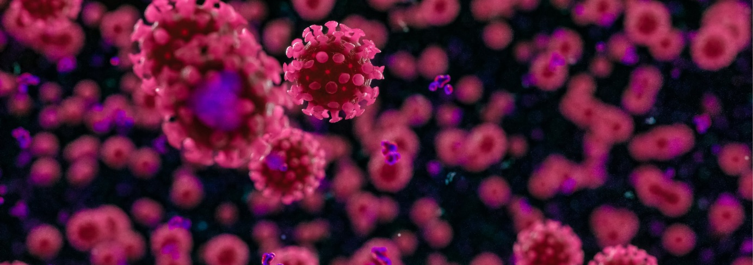
Covid-19

Reduce Your Risk

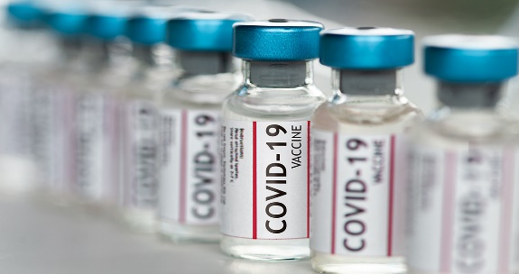
Get vaccinated and have your booster

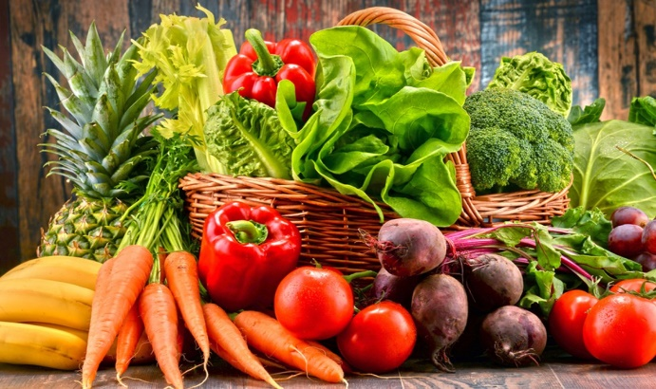
Eat more whole plant foods

The Zoe study of around
600,000 people showed that people who ate a diet rich in whole plant foods and low in processed foods were 10% less likely to get Covid-19 and 40% less likely to be hospitalised. Whole plant foods include fresh fruit and vegetables, whole grains, pulses, nuts and seeds.
This benefit was seen even after other factors like age, body mass index (BMI), ethnicity, smoking, physical activity and underlying health conditions were accounted for.

So why not start trying to eat more whole plant foods and less ready made/processed/refined foods to protect yourself against Covid (and for many other health benefits)
https://health-study.joinzoe.com/post/eating-a-plant-rich-diet-helps-to-protect-against-covid-19#part_1

